GitOps with ArgoCD

Continuous Delivery in Kubernetes

Class Labs: Revision 1.0 - 12/20/20

Brent Laster

**Important Note:** Prior to starting with this document, you should have the ova file for the class (the virtual machine already loaded into Virtual Box and have ensured that it is startable. See the setup doc jxi-setup.pdf in <http://github.com/brentlaster/safaridocs> for instructions and other things to be aware of. You should also have a GitHub account.

To-do for lab 1: put minikube and environment variables in a startup script.

Create meld file for updated yaml and save.

**Lab 1: Getting Started with Argo CD**

**Purpose:** In this lab, we'll start working with Argo CD by creating an app that represents our manifests and deploying that to the cluster.

1. To start, we'll need to get the minikube environment up and running. Open a terminal window and enter the command below.

$ sudo minikube start --vm-driver=none --addons=registry

1. Once your cluster starts up, you will have argocd running in its own argocd namespace. You can see the various pieces that are running there by looking at it in Kubernetes.

$ k get all -n argocd

1. Next, we need to login to our argocd instance. Our instance has been patched to run as a LoadBalancer service (instead of ClusterIP) using port 32322. Login to the running instance. The userid and password will be provided in the class. You can just answer y to the question that comes after the warning that pops up.

$ argocd login localhost:32322

1. Next we need to point argocd to the cluster we want to work with. Since we only have one cluster on this machine, it would default to that one automatically. But we'll go ahead and add it so we can see how its done.

$ argocd cluster add minikube

You should see output like the following:

﻿INFO[0000] ServiceAccount "argocd-manager" created in namespace "kube-system"

INFO[0000] ClusterRole "argocd-manager-role" created

INFO[0000] ClusterRoleBinding "argocd-manager-role-binding" created

Cluster 'https://10.0.2.15:8443' added

1. Let's set a couple of environment variables for convenience. The first one, ARGOCD_OPTS, tells the CLI which namespace ArgoCD is running in. You could skip this, but then you would have to supply that argument on every argocd command. The second variable tells ArgoCD where the API URL is for the target cluster.

$ export ARGOCD_OPTS='--port-forward-namespace argocd'

$ export CLUSTER_IP=https://$(sudo minikube ip):8443

1. Before we go further, let's open up the browser interface to Argo CD. Do that by opening up a browser and then going to the url <https://localhost:32322/> Accept any risk since we’re running a local version.

1. Now, we can create an "app" in Argo CD - essentially a way to manage the collection of Kubernetes manifests for services, deployments, etc. We'll use an existing set of manifests in GitHub for the ROAR webapp and database pieces. We'll also supply the destination cluster and namespace. Back in the terminal, enter the command below. (Note: Make sure you’ve done this in a terminal where the preceeding environment variables are set.)

﻿$ argocd app create roar-deploy-k8s --repo https://github.com/brentlaster/roar-deploy-k8s --path . --dest-server $CLUSTER_IP --dest-namespace roar

1. You should get a message like "application 'roar-deploy-k8s' created". And if you go back to the browser, you'll be able to see a representation for the app and the set of objects making it up. Click on the large, single box to see the set of items that make it up as shown below.

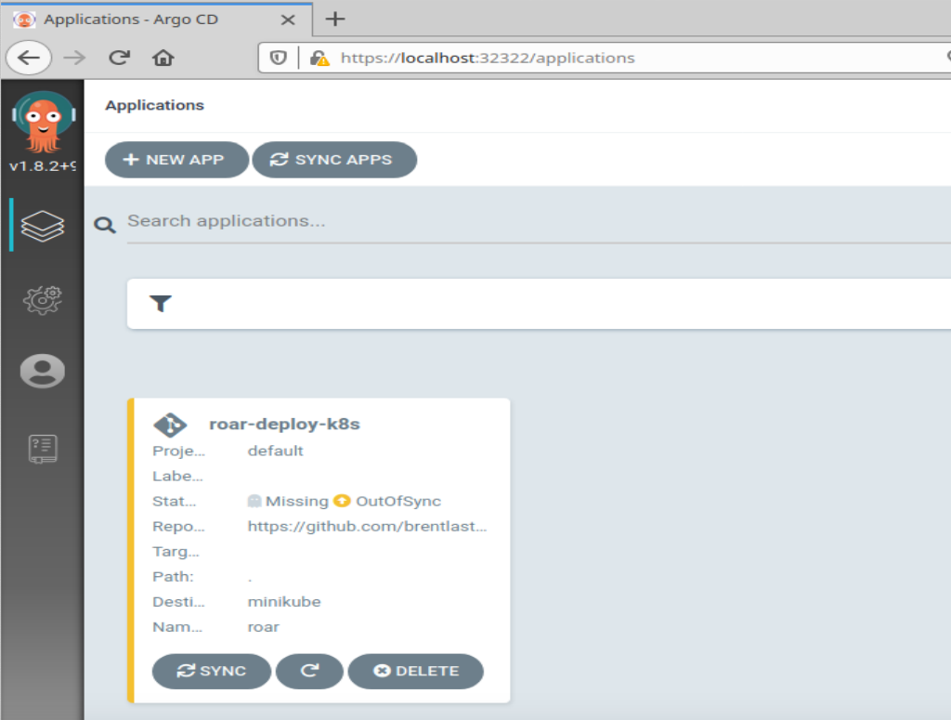

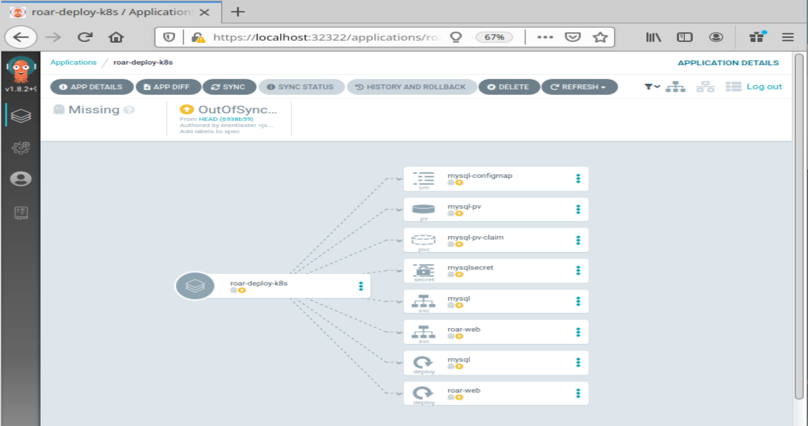

1. Back in the terminal, run the command below to see the current state of the app you just created.

$ argocd app list

The output should show you a number of fields with info about the app.

Notice that the STATUS is currently "OutOfSync" and HEALTH is currently "Missing". If you look in the browser you'll see these same indicators near the top of the screen.

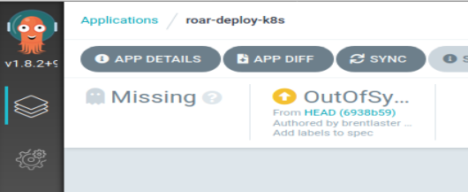

1. The reason for these is that while we've told Argo CD about the app, we haven't yet deployed it to the target cluster and namespace. Let's take a more detailed look at what will be deployed with our app.

$ argocd app get roar-deploy-k8s

Notice the set of KIND objects in the list and other information.

1. Before we sync our app, let’s make one edit to it to automatically create the namespace for us. Note that whether we use the command line or the UI to create the app, what we really get is a yaml file that is the “manifest” for the app. We can edit that to make changes. Edit the app and make the changes in the editor to add the yaml to automatically create the namespace. When you are done, save your changes and exit the editor. (You can ignore the Gtk warning message from the editor.)

$ export EDITOR=gedit

$ argocd app edit roar-deploy-k8s

Replace the last line “syncPolicy: { }” with the 3 lines below - pay attention to the spacing and speillng - see the screenshot as a reference.

﻿syncPolicy:

syncOptions:

- CreateNamespace=true

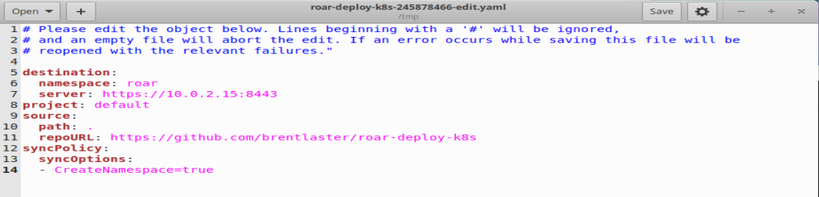

1. While ArgoCD can do automatic syncs to the target cluster and namespace, it defaults to manual syncs. So let's go ahead and tell it to sync now from the command line. Enter the command below.

$ argocd app sync roar-app

1. You’ll see updated status for the various kinds scroll by. And if you look back in the browser, you'll see that the sync has completed and things are starting up.

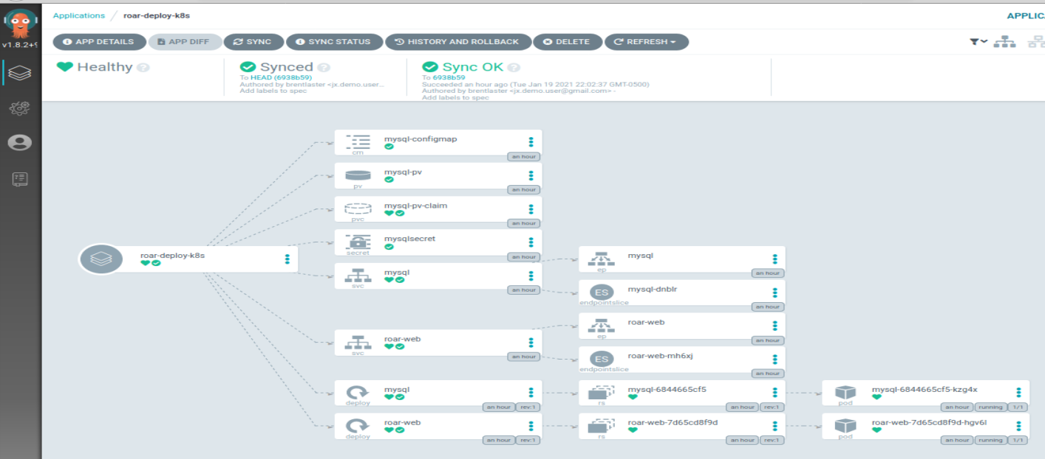

Optional:

1. You can click on either of the pod objects on the far right (with the cube icons) to see information about the object as its running in the cluster. The SUMMARY tab shows the live manifest of the object (spec + status). The EVENTS tab shows the Kubernetes events that have occurred, and the LOGS tab shows the logs from the application in the pod.

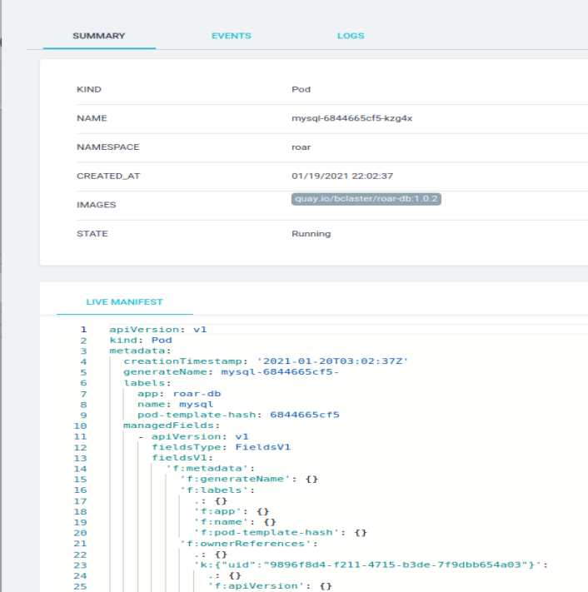

1. You can also see our app running in the cluster. From a command line, find the node port for the application and then open the URL shown below in a browser.

$ k get svc -n roar-web

Look for the port number that is between “8089:” and “/TCP”. Plug that in to the URL below.

[http://localhost:<port](http://localhost:%3cport) number>/roar/

You should see the app running similar to this screenshot.

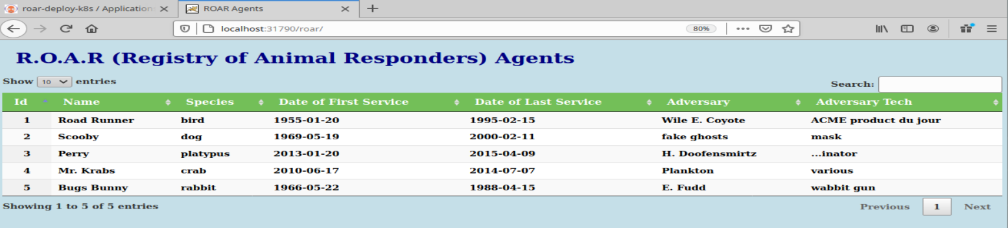

**Lab 2: Dealing with Failed Deployments and Rollback**

**Purpose:** In this lab, we’ll see what a failed deployment looks like and how to roll it back.

1. Let’s see what happens when a deployment fails. First, we’ll edit the app to change the Target Revision field.

Click on the main app icon on the far left, then click the EDIT button in the upper right.

1. In the parameters screen, edit the TARGET REVISION to change it from “HEAD” to “future”. Then click the SAVE button in the upper right corner to save the changes.

1. You’ll see the STATUS field immediately change to “OutOfSync”. Click the X in the upper left corner to close the parameters screen. Graphical user interface, text, application, email

   Description automatically generated
2. Now you can see which element is out of sync - the mysql deployment. Click on that element and then on the SUMMARY screen, in the DIFF tab, scroll down until you see the lines that are different. You can also see the manifest that is active in the cluster versus the one that is ready to be deployed by clicking on the LIVE MANIFEST vs DESIRED MANIFEST tabs, respectively. Close the screen by clicking on the “X” in the upper right corner when done.



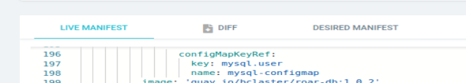

1. Manually synchronize the desired state to the cluster by clicking on the “SYNC” button on the top of the screen. When the popup appears, leave everything as it is and click on the “SYNCHRONIZE” button. After the sync is attempted, you’ll see that the app is in a “Progressing” state as it tries to reconcile the desired deployment with the live one. You’ll also notice that there is a pod that is not ready yet, indicated by the broken red heart icon. (See circled sections in the second screenshot below.)

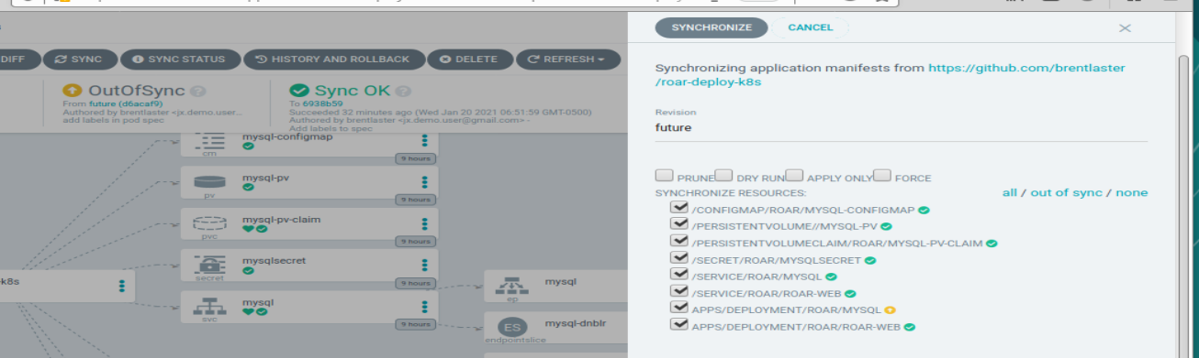

1. If you click on the un-synced pod element (the one with the broken red heart), you can see what is going on by looking at the EVENTS tab and at the pod logs from the LOGS tab.

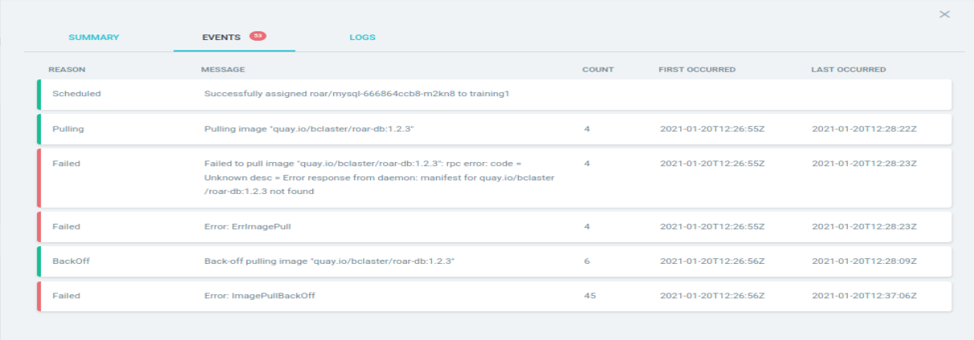

1. Eventually, the app status will switch to an overall status of “DEGRADED”. Note that your original deployment is still synched and running though.

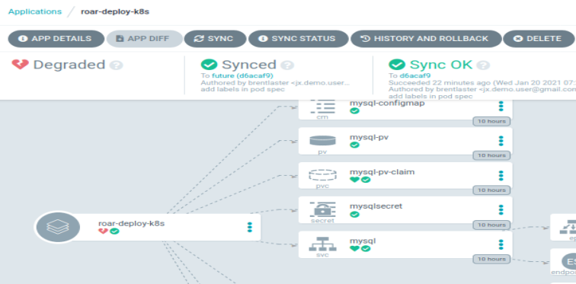

1. Let’s try another branch. Click the “SYNC” button at the top. Then in the pop-up dialog, change the “Revision” field to be “exp”. This represents an experimental branch on our project. After making that change, click on the “SYNCHRONIZE” button.

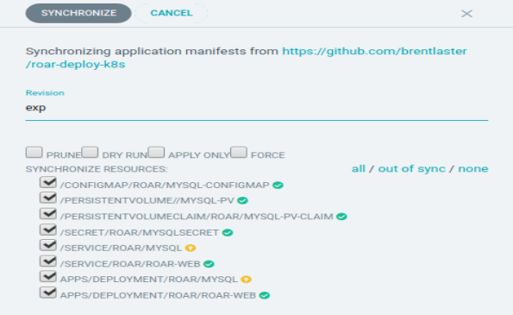

1. After this, you’ll be able to see that a couple of items still show up as “Out Of Sync” (yellow circle with arrows). This is because the version in the app is “future” and the version synched to the cluster is from the “exp” branch.

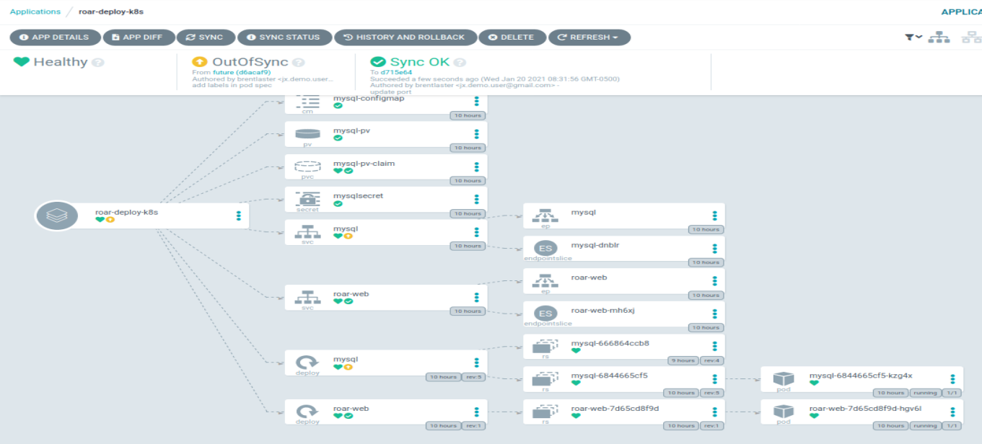

1. Now take a look at the app from “exp” running in the cluster. From a command line, find the node port for the application and then open the URL shown below in a browser.

$ k get svc -n roar-web

Look for the port number that is between “8089:” and “/TCP”. Plug that in to the URL below.

[http://localhost:<port](http://localhost:%3cport) number>/roar/

You’ll see something like below. Note that there is no data showing.

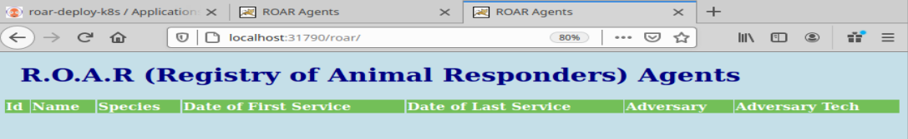

1. (Optional) If you want to see why this is broken, you can click on the revision link (“d715e64”) at the top of the screen to go to the code in GitHub.

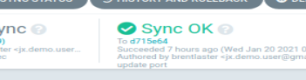 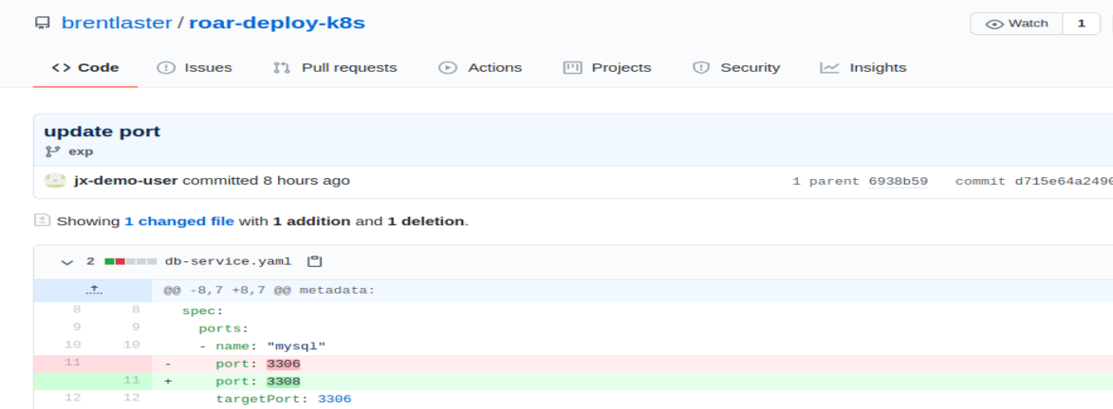



1. We want to rollback to a working state - meaning the original code deployed from main. To do that, click on the “HISTORY AND ROLLBACK” button at the top. You’ll then see a list of deployments like the one below.

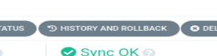

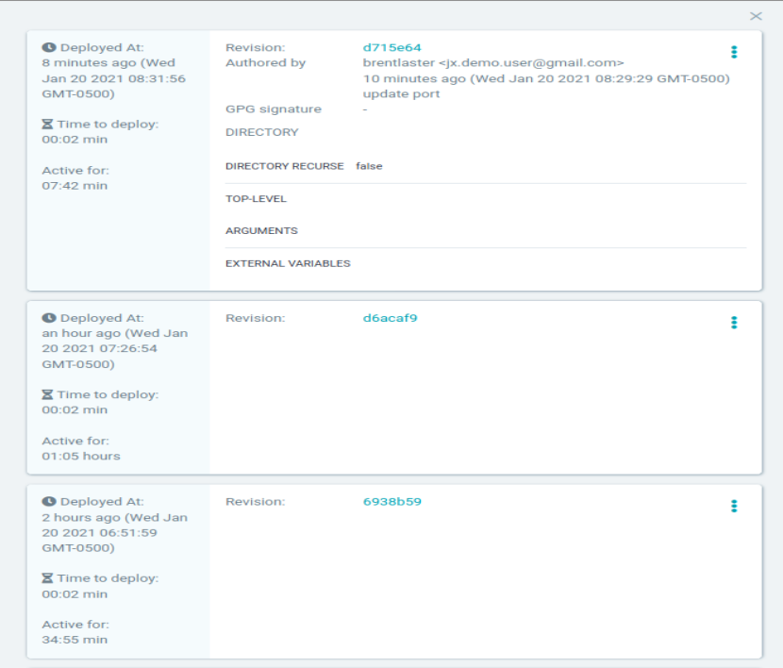

1. Find the entry for the original revision, click on the 3 dots on the right and then click on the “ROLLBACK” pop-up button.

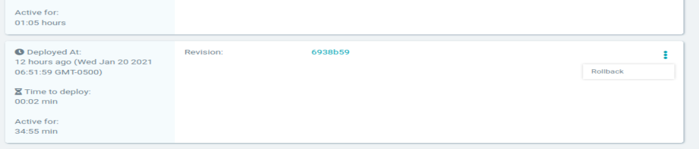

1. The rollback syncs the cluster back to the desired version, but does not modify the app. So, while the app still reflects the “future” settings, the cluster is now synched to the desired revision. You can see this at the top of the screen.

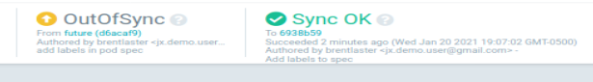

1. Now, assuming the service port hasn’t changed, if you refresh the screen where the roar web application is, you should see the version with the data in it - indicating that the correct version was applied back to the cluster.

Lab 3 prep

git clone <https://github.com/brentlaster/roar-k8s-helm.git> roar-k8s

cd ~/roar-k8s

rm -rf .git

git init

git add .

git commit -m “initial commit”

sudo su git

cd /git/repos

mkdir roar-k8s.git

cd roar-k8s.git

git init --bare

exit

git remote add origin [git@localhost:/git/repos/roar-k8s.git](mailto:git@localhost:/git/repos/roar-k8s.git)

git branch -m main

git push origin main:main

﻿sudo chmod -R u+wrx $HOME/.minikube'

﻿sudo chown -R $USER $HOME/.minikube

sudo su git

cd /git/repos

git symbolic-ref HEAD refs/heads/main

Lab 3: Helm Projects and Automated Sync

In this lab, we’ll see how to add a Helm project to ArgoCD with automatic synching. And then we’ll make a change to correct and issue and see the automatic sync in action.

1. First, let’s create a new project to work with instead of the default one. Create a new project with the command below.

$ argocd proj create helmproj

1. Now, we need to add local ssh information to argocd so the argocd pods can recognize the ssh requests for our local git repos. The middle command below will find and add ssh information to argocd. The top and bottom commands will show the entries before and after. (10.0.2.15 is the minikube ip address)

﻿$ argocd cert list --cert-type ssh

﻿$ ssh-keyscan 10.0.2.15 | argocd cert add-ssh --batch

$ argocd cert list --cert-type ssh

1. Now we’ll add a local Git repo as a repo for our project. After running the command below, you should see a message that indicates the repository was added.

$ ﻿argocd repo add git@10.0.2.15:/git/repos/roar-k8s.git --ssh-private-key-path ~/.ssh/id_rsa

1. Also add it to our project as a source AND add the cluster as a destination to the project with a namespace at the end.

$ argocd proj add-source helmproj [git@10.0.2.15:/git/repos/roar-k8s.git](mailto:git@10.0.2.15:/git/repos/roar-k8s.git)

$ ﻿argocd proj add-destination helmproj https://10.0.2.15:8443 helm-demo

1. Now, let’s create a new app definition in the UI for our project. Click on the “stack of squares” on the left side, then select the “+ NEW APP” button. Set the values as follows: (Notice that along the way, ArgoCD recognizes there are Helm charts in the repo and automatically adds the “Helm” section at the bottom.)

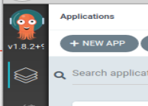

GENERAL

Application Name = helm-demo

Project = helmproj

SYNC POLICY = Automatic

SYNC OPTIONS - check both boxes

SOURCE

Repository URL = [git@10.0.2.15:/git/repos/roar-k8s.git](mailto:git@10.0.2.15:/git/repos/roar-k8s.git)

Revision = HEAD

Path = helm

DESTINATION

Cluster URL = <https://10.0.2.15:8443>

Namespace = helm-demo

HELM

This section will have already found our root/global values.yaml file and populated the PARAMETERS section from it. You can leave it as-is.

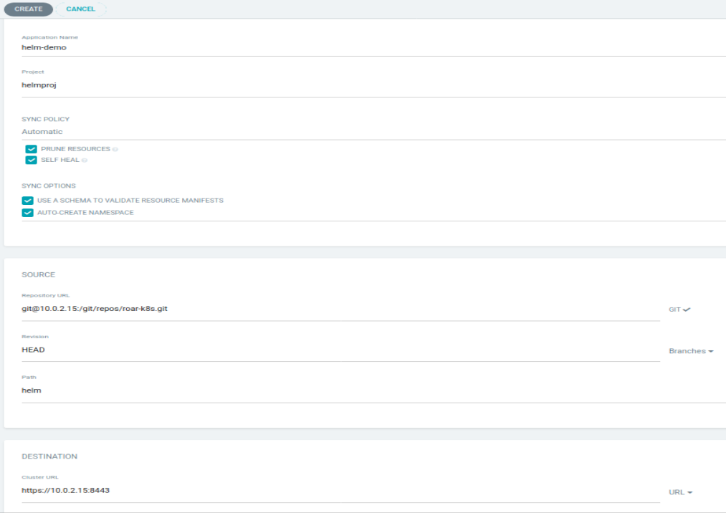

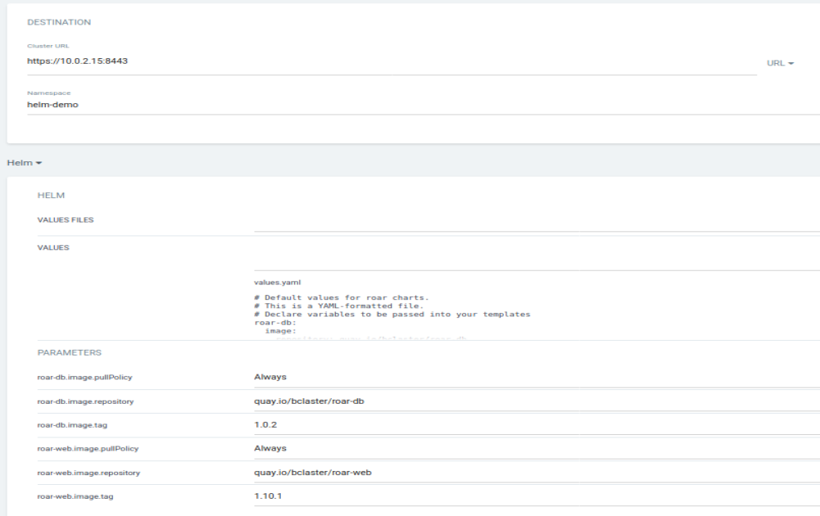

1. When you’re done, click on the “CREATE” button at the top to save the app. You should see the new app automatically going through the “Progressing” stage while it tries to get things starting up. However, there is a problem with the web pod as indicated by the red broken heart.

﻿

1. Click on that item and look at the SUMMARY and/or EVENTS tabs to see what’s wrong.

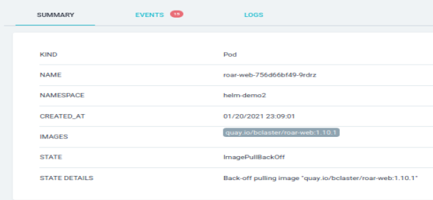 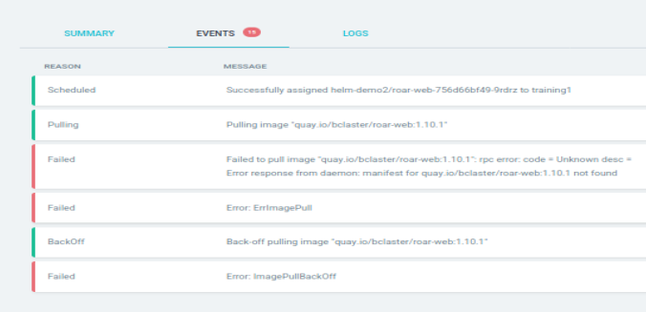

1. The deployment can’t get the requested disk image. The reason is that there is a typo here in the images semantic version tag: Instead of “1.10.1”, it should be “1.0.1”. Let’s fix that with the following sequence. (All commands should be run in a terminal)

$ git clone [git@10.0.2.15:/git/repos/roar-k8s.git](mailto:git@10.0.2.15:/git/repos/roar-k8s.git)

$ cd roar-k8s/helm

$ gedit values.yaml

Change the tag on line 12 from “1.10.1” to “1.0.1”, save your changes and exit the editor.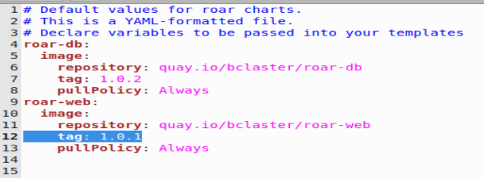

$ git diff (This is just to verify this is the only change that has been made in your repo.)

$ git commit -am “Fix version number”

$ git push origin main

1. After this, you can go back to the main app page. Your app status will probably be showing “Degraded” at this point. After about 3 minutes or so (be patient), the automated sync setting will kick in and the stage will change to “Progressing” and eventually should all go green.

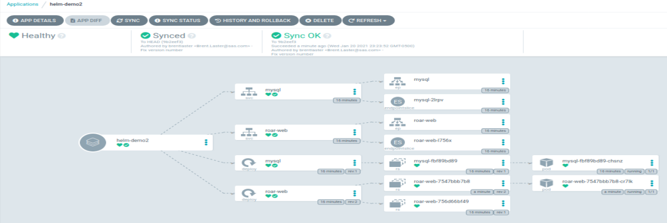

1. (Optional) If you want, you can find the service node port and use it to look at the running app as we’ve done before.
2. Verify that the chart installation created a release in the cluster. What revision is it?

$ helm list

Sync

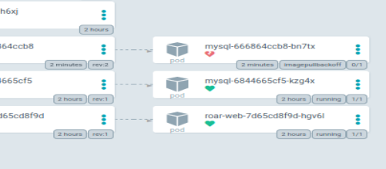

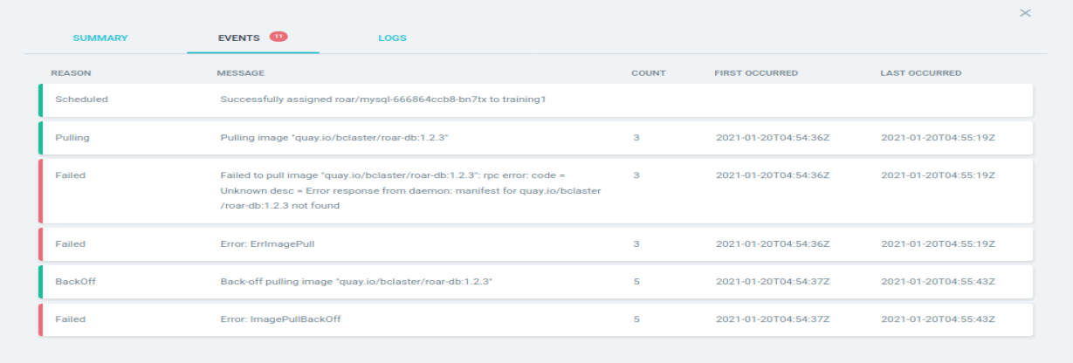

k get pods -n roar

show “progressing” and eventually “degraded”

then use history to rollback

notice still has error

1. Notice the output you got when you did the helm install in step 8. This is telling us that in order to access this in the browser, we need to forward the port from within the cluster out. To save you typing/copying all of this, there is already a simple script that does this in the home directory named ./cm-port.sh. Run the script.

$ ./cm-port.sh

1. Verify that chartmuseum is up and running and accessible by opening up a browser from the upper left menu (see screenshot) and selecting web browser. Then **go to localhost:8080** and ensure you see the chartmuseum welcome message.

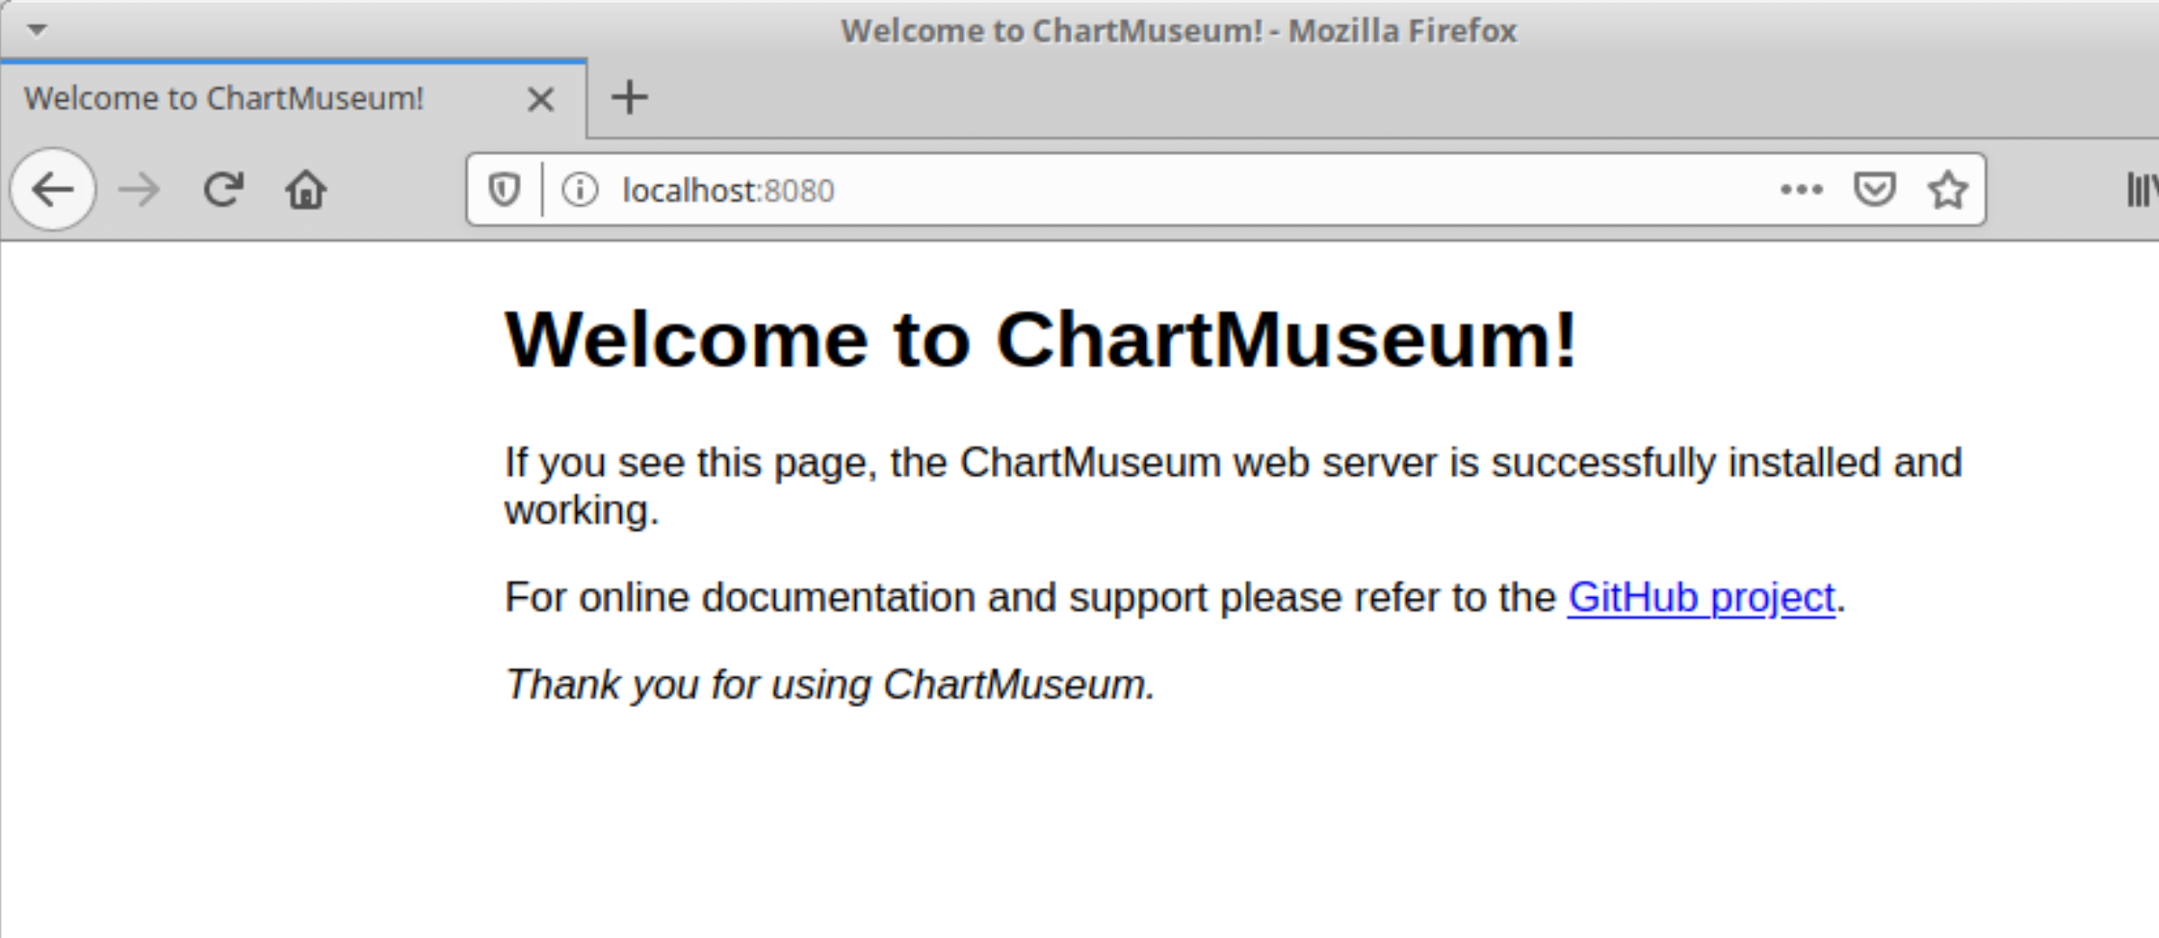

**Lab 2: Changing values**

**Purpose:** In this lab, you’ll get to see how we can change values and upgrade releases through Helm, as well as learn some more Helm commands.

1. While we have ChartMuseum running, it would be nice not to have to also run the port forwarding script. The service that runs in the Kubernetes cluster for ChartMuseum is defaulted to be of type "ClusterIP" - mainly intended for traffic internal to the cluster. To see that, open a second terminal window and run the command to get the service info for the namespace where ChartMuseum is running. (The Kubernetes command line application, kubectl, is aliased to “k” on this machine.)

$ k get svc

Notice the output indicating the type of service is ClusterIP.

1. To be able to change this, we'll want to change the service type for our chartmuseum instance to be NodePort instead of ClusterIP. That will let us have a node in the range 30000-32767 that can be used for access. Let's first see what values we have that can be changed in our chartmuseum chart

$ helm show values stable/chartmuseum

1. Lots of information there, but we'd like to change only the chart type and assign a node port. Let's look for the information around the text "ClusterIP"

$ helm show values stable/chartmuseum | grep -n10 ClusterIP

1. Notice under the output, in the "service" section, we have the "type" set to ClusterIP and an empty setting for "nodePort".
2. Remind yourself of what release you currently have out there.

$ helm list

1. Go ahead and stop the port-forwarding that was running in the other window (via Ctrl-C).

$ Ctrl-C

1. We want to upgrade the service.type and service.nodePort values in our Helm release. How do we do that on the command line? Take a look at the first part of the help for helm upgrade.

$ helm upgrade --help | head

1. Notice the last line about being able to use the --set option to override values from the command line. We'll run an upgrade and try that - explicitly setting the service.type to NodePort and the node port itself to 31000. (You may want to copy and paste this one)

$ helm upgrade local-chartmuseum stable/chartmuseum --set env.open.DISABLE_API=false --set service.type=NodePort --set service.nodePort=31000

1. Take a look at the release you have out there now, its status and its history

$ helm list

$ helm status local-chartmuseum

$ helm history local-chartmuseum

1. Verify that the type of port has been changed for the running version.

$ k get svc

You should see it listed as a NodePort now with 31000 as the exposed port.

1. Now we'll add your chartmuseum repo to your list of repos for Helm and verify it's there.

$ helm repo add local <http://localhost:31000>

$ helm repo list

**Lab 3: Creating a Helm Chart**

**Purpose:** In this lab, we'll create a simple Helm chart and add it to our new repository

1. Let's use Helm to create a simple, default chart one that will spin up an nginx deployment.

$ helm create sample-chart

1. Let's see what Helm created in terms of the structure of files and directories.

$ tree sample-chart

1. Now take a look at some of the main files in the new chart.

$ cd sample-chart

$ cat Chart.yaml

$ cat values.yaml

$ cat templates/deployment.yaml

$ cat templates/service.yaml

1. Take a look at how Helm would render files in this chart.

$ helm template --debug . | head -n 50

1. Go ahead and install the chart.

$ helm install sample .

You will see some output like this:

﻿*NAME: sample*

*LAST DEPLOYED: Sun Jun 7 22:00:07 2020*

*NAMESPACE: default*

*STATUS: deployed*

*REVISION: 1*

*NOTES:*

*1. Get the application URL by running these commands:*

*export POD_NAME=$(kubectl get pods --namespace default -l "app.kubernetes.io/name=sample-chart,app.kubernetes.io/instance=sample" -o jsonpath="{.items[0].metadata.name}")*

*echo "Visit http://127.0.0.1:8080 to use your application"*

*kubectl --namespace default port-forward $POD_NAME 8080:80*

1. If you do a helm list command, you'll see that the chart was deployed in the "default" namespace (alongside our chart-museum one) and note that it is release version 1. You can also see the Kubernetes objects that were deployed in the default namespace for this.

$ helm list

$ k get all | grep sample

1. Take a look at the rendered templates that got deployed into the cluster.

$ helm get manifest sample | head -n 50

This should look very similar to the output from the template command that was issued earlier.

1. You may have noticed earlier that this chart had a test built into it. Let's run the test now. Note the output and also note the pods that are there afterwards. Then take a look at the definition of the test afterward and see if you can understand how it all ties together.

$ helm test sample

$ k get pods

$ cat templates/tests/test-connection.yaml

1. We're done with this release now, so we can delete it.

$ helm delete sample

1. Take a look at the objects in the default namespace to see that the sample ones were removed. You may see a leftover test pod that did not get removed. If so, use the second command below to remove it.

$ k get all | grep sample

$ k delete pod *<sample-pod-name>*

**Lab 4: Charts and Dependencies**

**Purpose:** In this lab, we’ll deploy the chart for our sample webapp, and then see how to add another chart as a dependency for its database.

1. On your local machine is a directory with a set of projects that we'll be using in this class. There are subdirectories for different sections. Go to that directory. You can optionally look at any of the files you're interested in.

$ cd helm-ws/roar-web

$ cat <files of interest>

1. Create a namespace for the database to run in and then deploy it via Helm

$ kubectl create ns roar

$ helm install -n roar roar .

Afterwards you should see a set of output like the following:

﻿*NAME: roar*

*LAST DEPLOYED: Wed Jun 3 22:23:59 2020*

*NAMESPACE: roar*

*STATUS: deployed*

*REVISION: 1*

*TEST SUITE: None*

1. Take a look at the release that has been installed in the cluster.

$ helm list -n roar

You should see output like the following:

*﻿ ﻿NAME NAMESPACE REVISION UPDATED STATUS CHART APP VERSION*

*roar roar 1 2020-06-03 22:23:59.206949569 -0400 EDT deployed roar-web-0.1.0*

Now take a look at the resources that are installed in the cluster.

$ kubectl get all -n roar

1. Find the nodeport where the app is running and open it up in a browser.

$ kubectl get svc -n roar

Look for the NodePort setting in the service output (should be a number > 30000 after "8089:")

In a browser, go to [http://localhost:<NodePort>/roar/](http://localhost:%3cNodePort%3e/roar/)

You should see something like this:

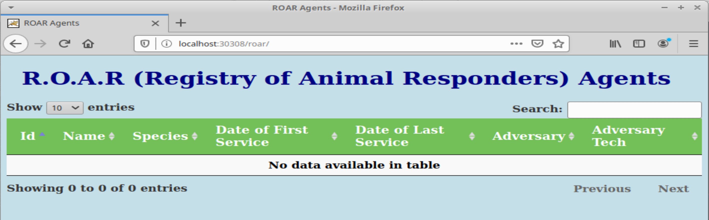

1. Notice that we see our webapp, but there is no data in the table. This is because we don't have our database deployed and being pulled in. We have a database chart and resources on our local system. Let's see how to get it pulled in as a dependency. First, change into the directory for the database pieces. Again, you can look at any files of interest in there.

$ cd ~/helm-ws/roar-db

$ cat <files of interest>

1. We want to package this up so it can be used as a dependency for our web chart. Go ahead and run the command to package it up. You should be in the roar-db subdirectory still.

$ helm package .

For output, you should see something like this:

﻿*Successfully packaged chart and saved it to: /home/diyuser3/helm-ws/roar-db/roar-db-0.1.0.tgz*

1. Upload the newly created package to our ChartMuseum instance.

$ ﻿curl --data-binary "@roar-db-0.1.0.tgz" <http://localhost:31000/api/charts>

When done, you should see output like this:

*{"saved":true}*

1. Now that we have this package stored in our chart repository, we can add it as a dependency into our webapp's chart so it will have data to display. To do that we go back to the webapp's chart directory and create a requirements.yaml file.

$ cd ~/helm-ws/roar-web

$ gedit Chart.yaml

Add the **lines in bold** below (the dependencies section) - this would have been handled with a requirements.yaml in an earlier version of Helm.

﻿apiVersion: v1

description: Helm chart for roar-web instance

name: roar-web

version: 0.1.0

**dependencies:**

**- name: roar-db**

**version: 0.1.0**

**repository:** [**http://localhost:31000**](http://localhost:31000)

1. Save your changes to the Chart.yaml file and update dependencies.

﻿$ helm dep up

You should see output like this as Helm gets your new dependency:

*Hang tight while we grab the latest from your chart repositories...*

*...Successfully got an update from the "local" chart repository*

*...Successfully got an update from the "stable" chart repository*

*Update Complete. ⎈Happy Helming!⎈*

*Saving 1 charts*

*Downloading roar-db from repo http://localhost:31000*

*Deleting outdated charts*

1. If you look at the directory structure now, you'll have a new "charts" directory where the tgz file will be. With our new dependency in place, let's remind ourselves what is out there now and then go ahead and upgrade our webapp release.

$ ls charts

$ helm list -n roar

$ k get all -n roar

$ helm upgrade -n roar roar . --recreate-pods

1. Take a look at what we have out there now for this release.

$ helm list -n roar

$ k get all -n roar

You should see the various database pieces in the cluster now.

1. Finally, refresh the webapp in your browser and you should see data being displayed.

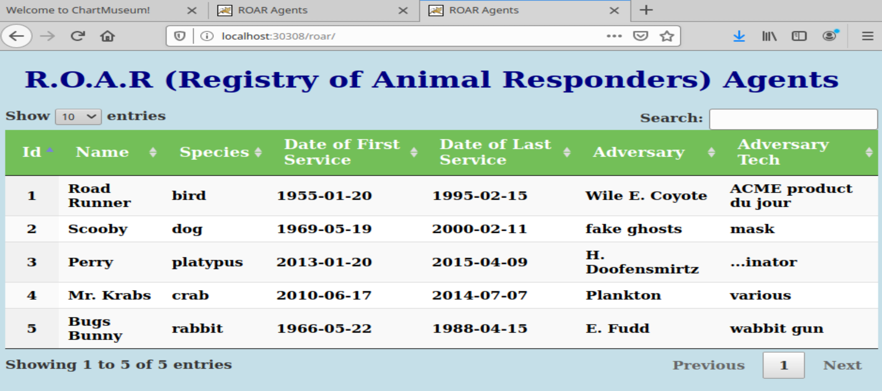

**Lab 5: Templating**

**Purpose:** In this lab, we'll see how to add templating to a manifest file and also another way to specify values and setup dependencies.

1. Let's suppose we want to create a helm deployment passing in a test database. We're going to change our dependency to be an actual copy of the chart so we can work with it more easily.

$ cd ~/helm-ws

$ rm -rf charts/*

$ cp -R ../roar-db charts/

1. Take a look at the deployment.yaml in the sub-chart. Notice that the image name is hardcoded and not templated.

$ cat charts/roar-db/templates/deployment.yaml

﻿ - name: {{ .Chart.Name }}

**image: bclaster/roar-db-image:v1**

imagePullPolicy: Always

ports:

1. Edit the file and change that line to a templated form:

$ gedit charts/roar-db/templates/deployment.yaml

Change line 19 from

image: bclaster/roar-db-image:v1

to

﻿image: "{{ .Values.image.repository }}:{{ .Values.image.tag }}"

Make sure that the indentation still lines up as before:

containers:

- name: {{ .Chart.Name }}

**image: "{{ .Values.image.repository }}:{{ .Values.image.tag }}"**

imagePullPolicy: Always

ports:

Save the file and close the editor.

1. Now let's check our charts to make sure they're valid via the Helm lint function (you should still be in the roar-web directory).

$ helm lint --with-subcharts

What messages do you see? What does the error mean?

1. There's a "*nil pointer evaluation*" because we haven't yet defined anything in values.yaml for "Values.image.repository" or "Values.image.tag". Let's fix that now.

$ gedit charts/roar-db/values.yaml

Change the top from this

﻿# Default values for roar-db-chart.

# This is a YAML-formatted file.

# Declare variables to be passed into your templates.

replicaCount: 1

nameOverride: mysql

deployment:

ports:

name: mysql

containerPort: 3306

to this:

﻿# Default values for roar-db-chart.

# This is a YAML-formatted file.

# Declare variables to be passed into your templates.

**image:**

**repository: bclaster/roar-db-image**

**tag: v1**

replicaCount: 1

nameOverride: mysql

deployment:

ports:

1. Save your changes and exit the editor. Then run the lint check again.

$ helm lint --with-subcharts

This time you should not see any errors (though you will still see INFO messages).

1. Create a new namespace and deploy this new version of the chart.

$ k create ns roar2

$ helm install roar2 -n roar2 .

1. Find the nodeport and open up the webapp from the release in a browser.

$ k get svc -n roar2

Find the NodePort value (will be > 30000)

In the browser, go to [http://localhost:<NodePort](http://localhost:%3cNodePort) value>/roar/

Here you should see the same webapp and data as before.

1. Let's suppose we want to overwrite the image used here to be one that is for a test database. The image for the test database is on the Docker hub at bclaster/roar-db-test:v2 .

We could use a long command line string such as this to set it and use the template command to show the rendered files. Run the commands below to see the difference.

$ helm template . --debug | grep image

﻿$ helm template . --debug --set roar-db.image.repository=bclaster/roar-db-test --set roar-db.image.tag=v2 | grep image

1. It's not always convenient to have to override things on the command line. But there are other ways to override values. Let's create a simple "extra" values file.

$ gedit test-db.yaml

In the editor, add the following lines:

﻿roar-db:

image:

repository: bclaster/roar-db-test

tag: v4

(For convenience, there is a test-db.yaml file in the "extra" area of the helm-ws area.)

Save your changes to the file and exit the editor.

1. Now, in one of your terminal windows, start a watch of the pods in your deployed helm release. This is so that you can see the changes that will happen when we upgrade. Save your changes to the file, and run the following command to pull in your custom definitions.

$ kubectl get pods -n roar2 --watch

1. Finally, let's do an upgrade using the new values file. In a separate terminal window from the one where you did step 11, execute the following command:

$ helm upgrade -n roar2 roar2 . -f test-db.yaml --recreate-pods

Watch the changes happening to the pods in the terminal window with the watch running.

1. Go back to your browser and refresh it. You should see a version of the (TEST) data in use now.

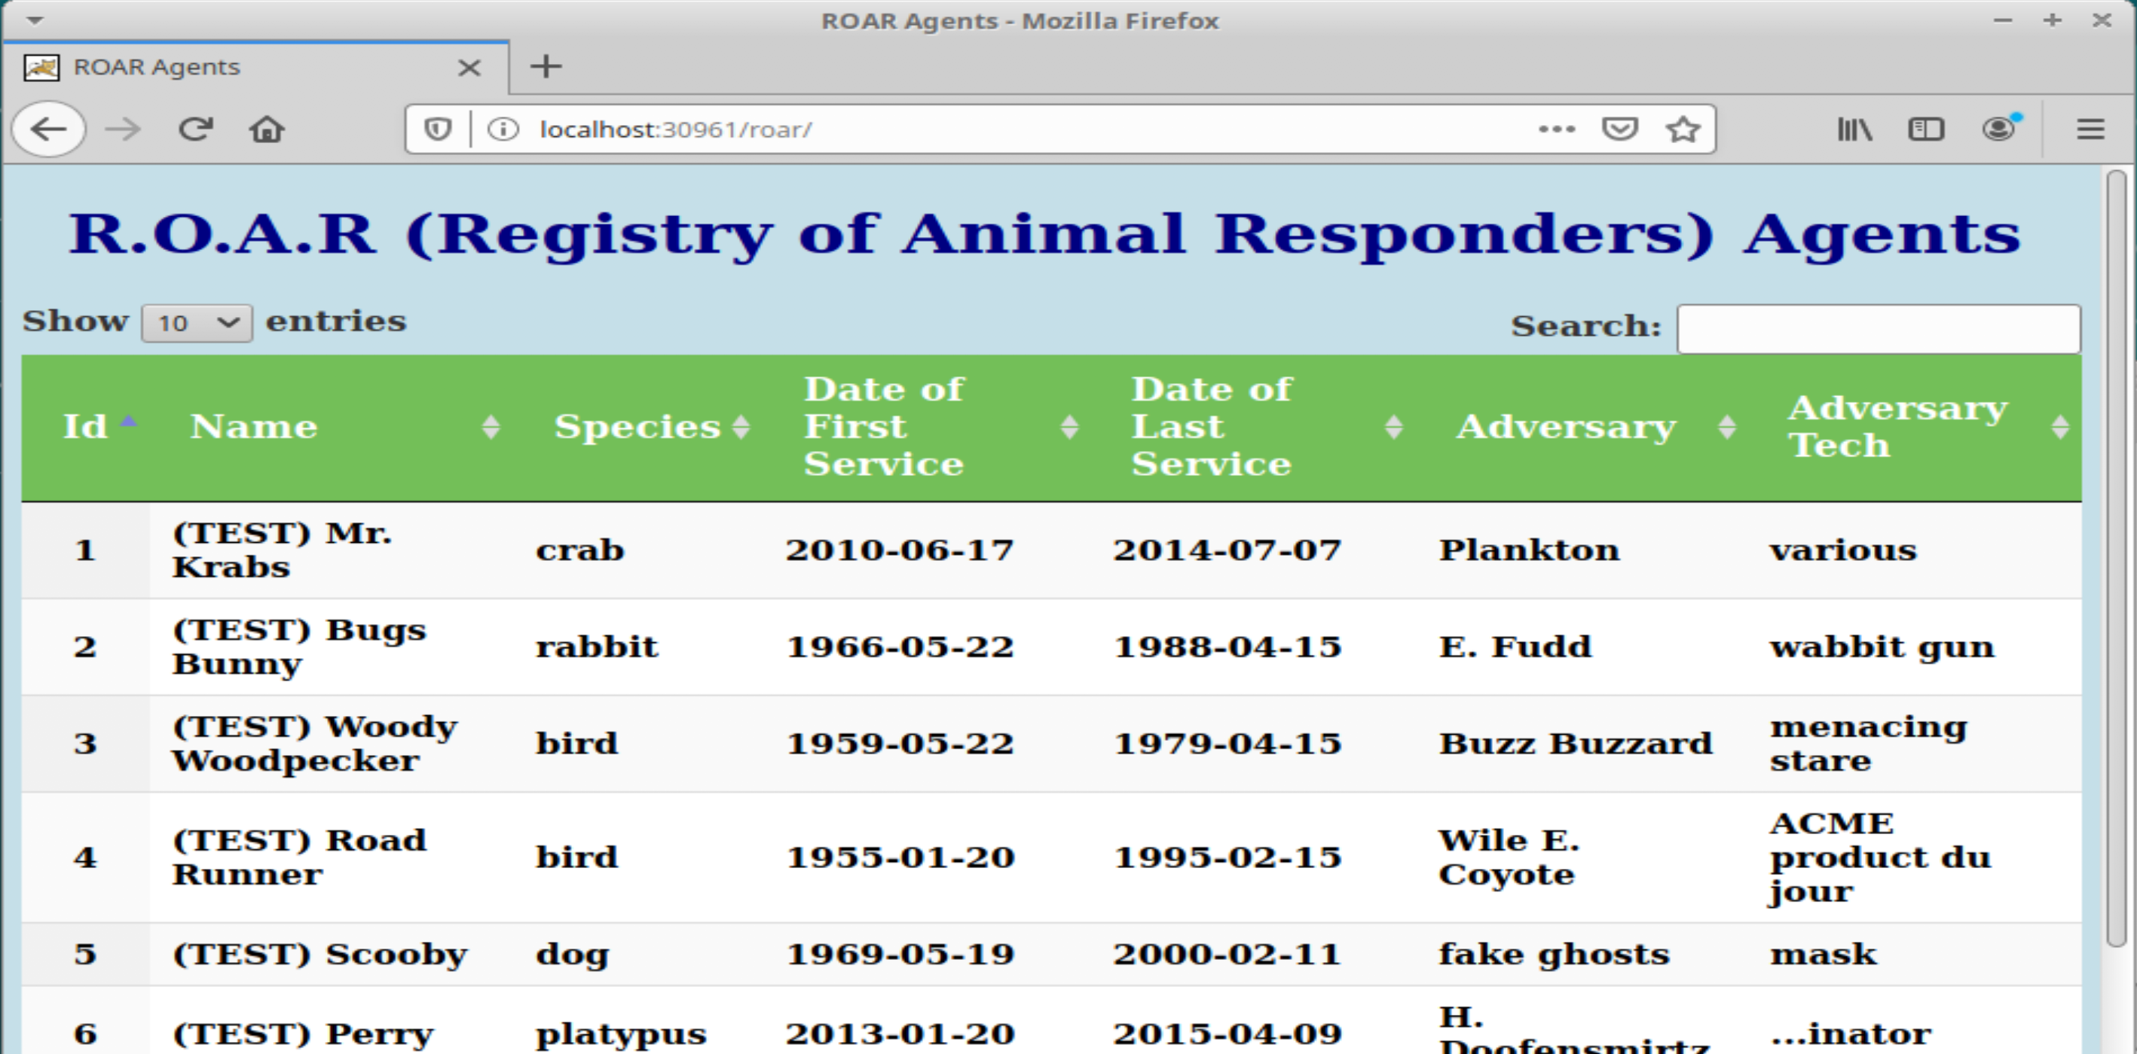

1. Go ahead and stop the watch from running in the window via Ctrl-C.

$ Ctrl-C

**Lab 6: Using Functions and Pipelines**

**Purpose:** In this lab, we'll see how to use functions and pipelines to expand what we can do in Helm charts.

1. In our last lab, we added a separate values file that we could use to swap out which database we used - the prod one or the test one. Now let's work on a way to do this based on a simple command line setting rather than having to have a separate file with multiple values. To start, let's make a copy of our working project that already functions. And then go to that directory.

$ cd ~/helm-ws

$ cp -R roar-web roar-web2

$ cd roar-web2

1. For switching between the prod and test database, we'll add two different versions of the image to choose from - one for prod and one for test. Edit and modify the *charts/roar-db/values.yaml* file and add the following values. (For reference, or if you're concerned about the typing, in the ~/helm-ws/extra folder, there is a values.yaml with the code already in it.)

$ gedit charts/roar-db/values.yaml

Add the following lines

﻿image:

prod:

repository: bclaster/roar-db-image

tag: v1

test:

repository: bclaster/roar-db-test

tag: v4

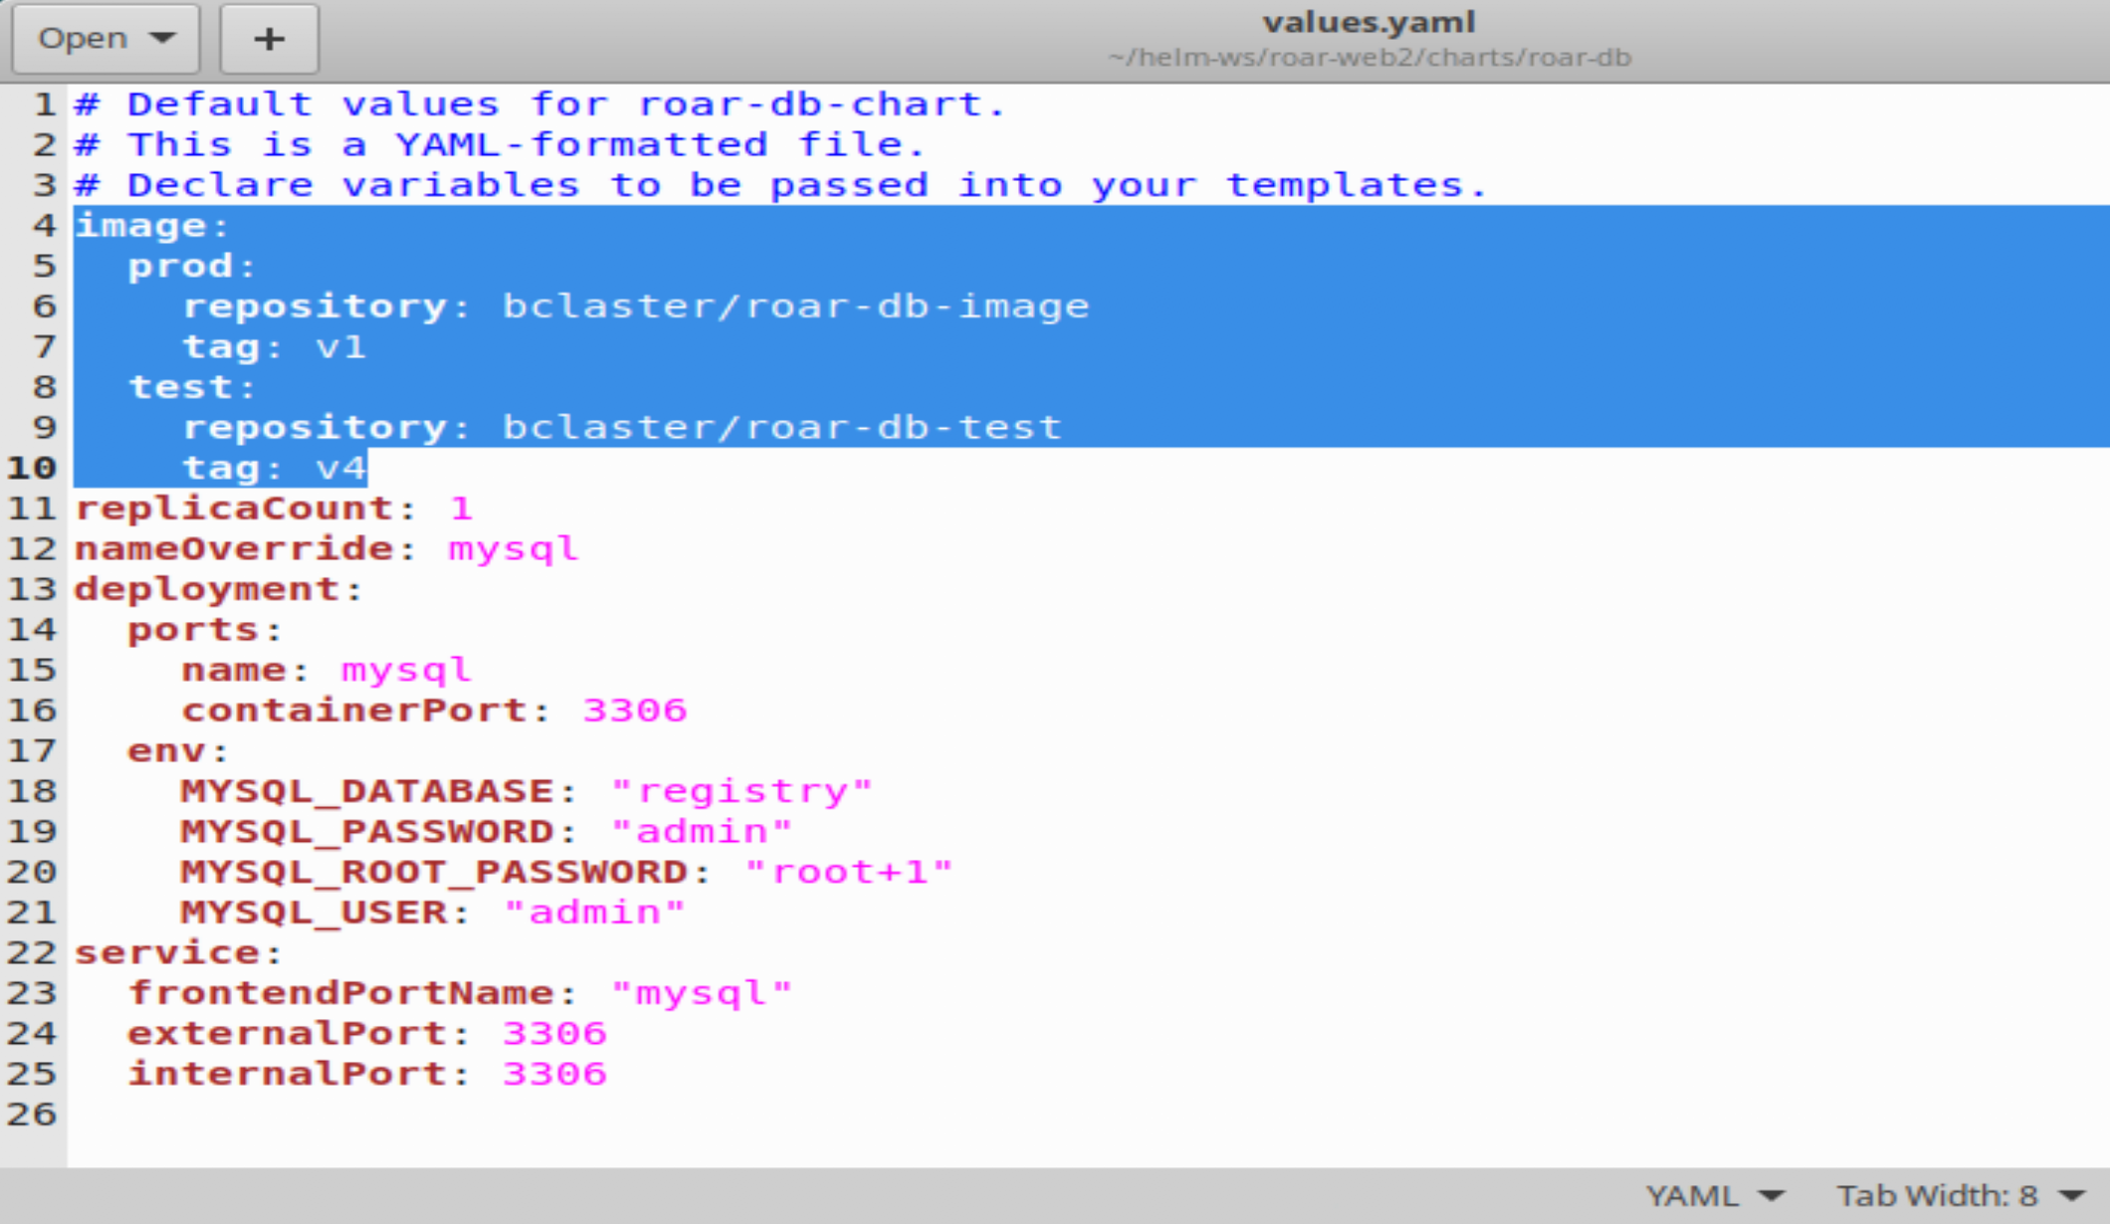

1. Now, we'll add some processing to enable selecting one of these images based on passing a setting for "stage" of either "PROD" or "TEST". The design logic is

*if stage = PROD*

*use image.prod.repository : image.prod.tag*

*else if stage = TEST*

*use image.test.repository : image.test.tag*

*else*

*display error message that we don't have a valid stage setting*

Translating this into templating syntax, we use an if/(else if)/else flow. The "eq" function is used for comparison, passing the two things to compare after it. Also, there is a "required" function that will handle the default error checking. Putting it all together, it could look like this:

{{- if eq .Values.stage "PROD" }}

image: "{{- .Values.image.prod.repository }}:{{ .Values.image.prod.tag -}}"

{{ else if eq .Values.stage "TEST" }}

image: "{{- .Values.image.test.repository }}:{{ .Values.image.test.tag -}}"

{{ else }}

image: "{{- fail "A valid .Values.stage entry required!" }}"

{{ end -}}

1. Edit the *charts/roar-db/templates/deployment.yaml* file and add the if - end template pieces above into the containers section as shown below.

(For convenience or if you have trouble with typing it in, there is a deployment.yaml file in the extras area.)

$ gedit charts/roar-db/templates/deployment.yaml

<add in lines>

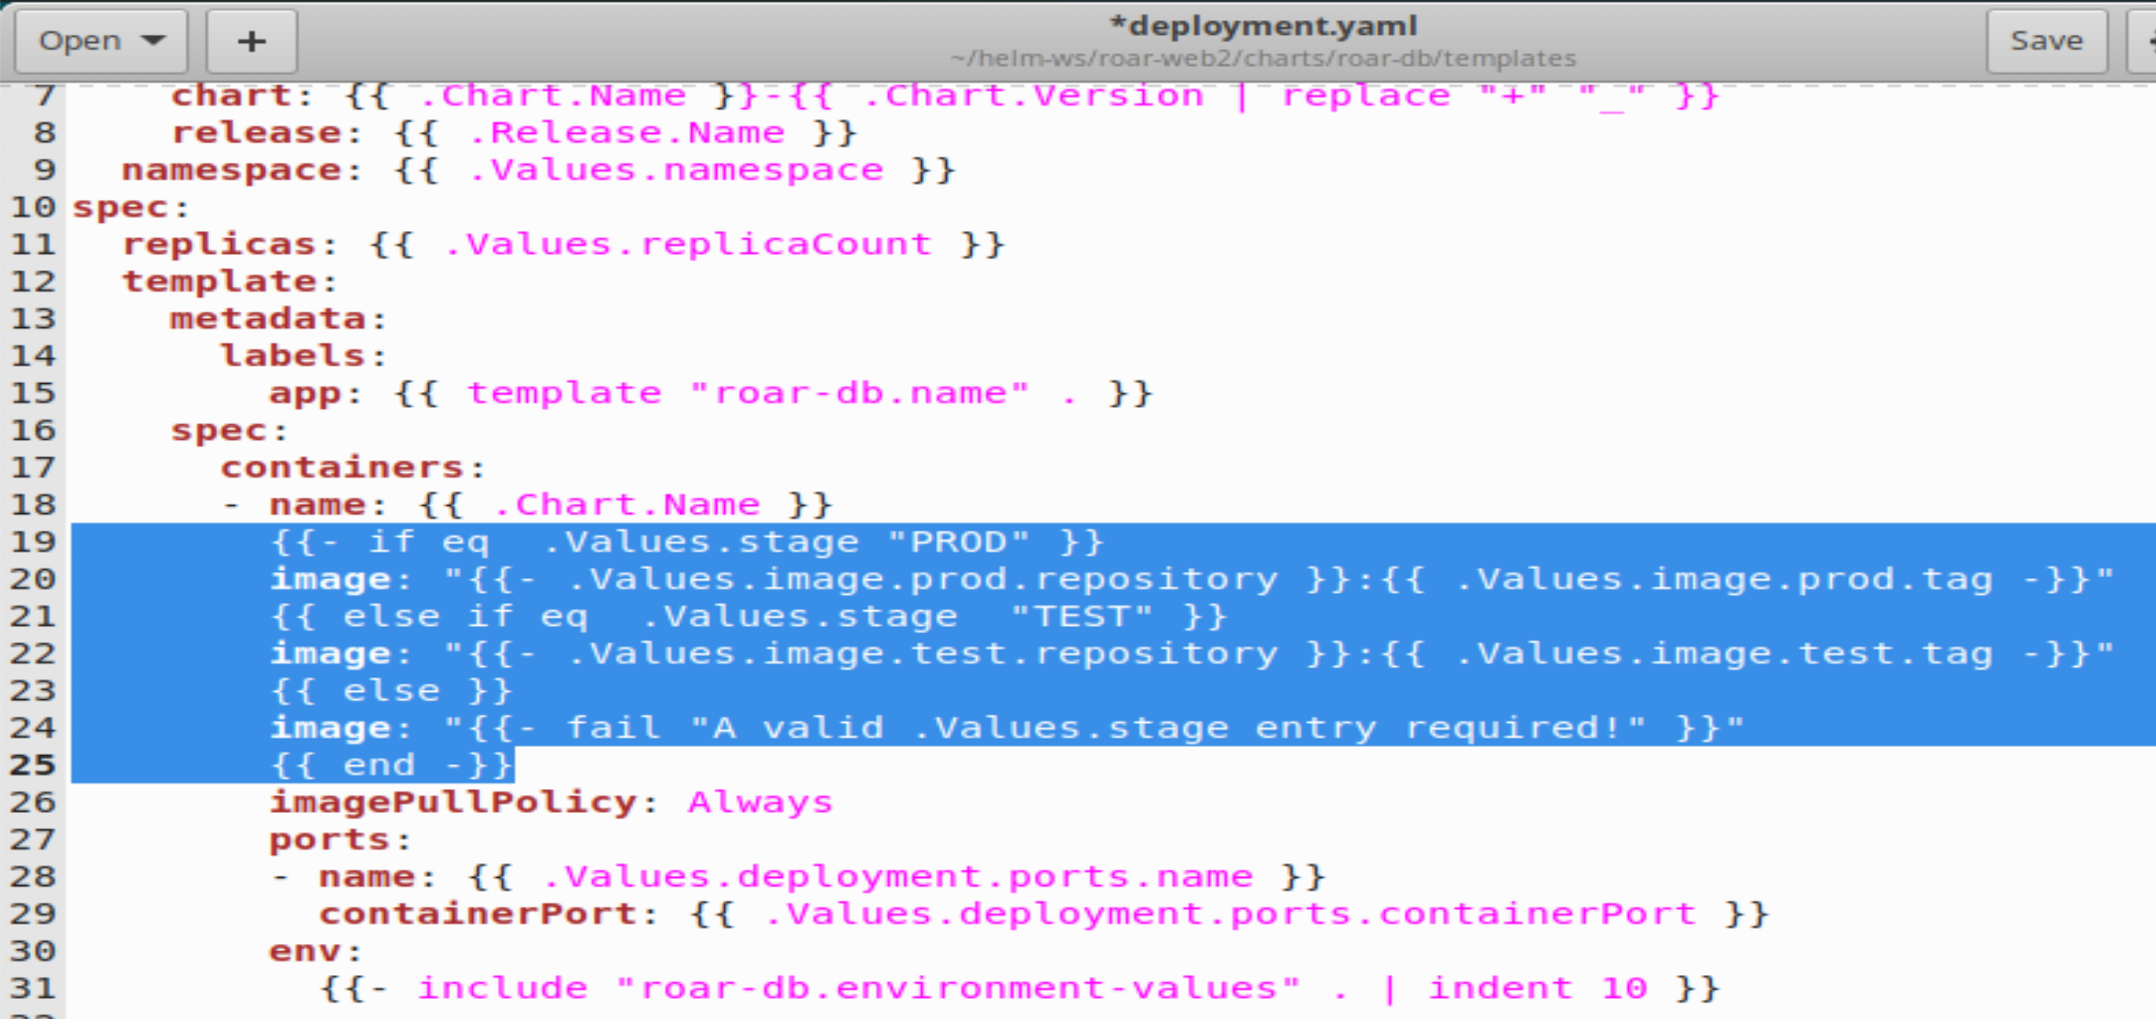

1. Save your changes and do a dry-run to make sure the image comes out as expected. To simplify seeing the change, we'll grep for image with a few lines of context.

$ helm install --set roar-db.stage=TEST --dry-run FOO . | grep image -n3

You should see output like the following:

﻿*65- spec:*

*66- containers:*

*67- - name: roar-db*

*68: image: "bclaster/roar-db-test:v4"*

*69: imagePullPolicy: Always*

*70- ports:*

*71- - name: mysql*

*72- containerPort: 3306*

*--*

1. While this appears to work, what happens if we pass a lower-case value?

$ helm install --set roar-db.stage=test --dry-run FOO . | grep image -n3

Notice the output has

﻿68: image: "test"

This is not what we want. Let's make our arguments case-insensitive. To do this, we'll pipe the value we pass in through a pipeline and to another template function called "upper" to upper-case it first.

1. Edit the deployment file and make the changes shown below.

$ gedit charts/roar-db/templates/deployment.yaml

Change line 19 from

﻿{{- if eq .Values.stage "PROD" }}

to

﻿{{- if eq ( .Values.stage | upper ) "PROD" }}

and change line 21 from

{{ else if eq .Values.stage "TEST" }}

to

{{ else if eq ( .Values.stage | upper ) "TEST" }}

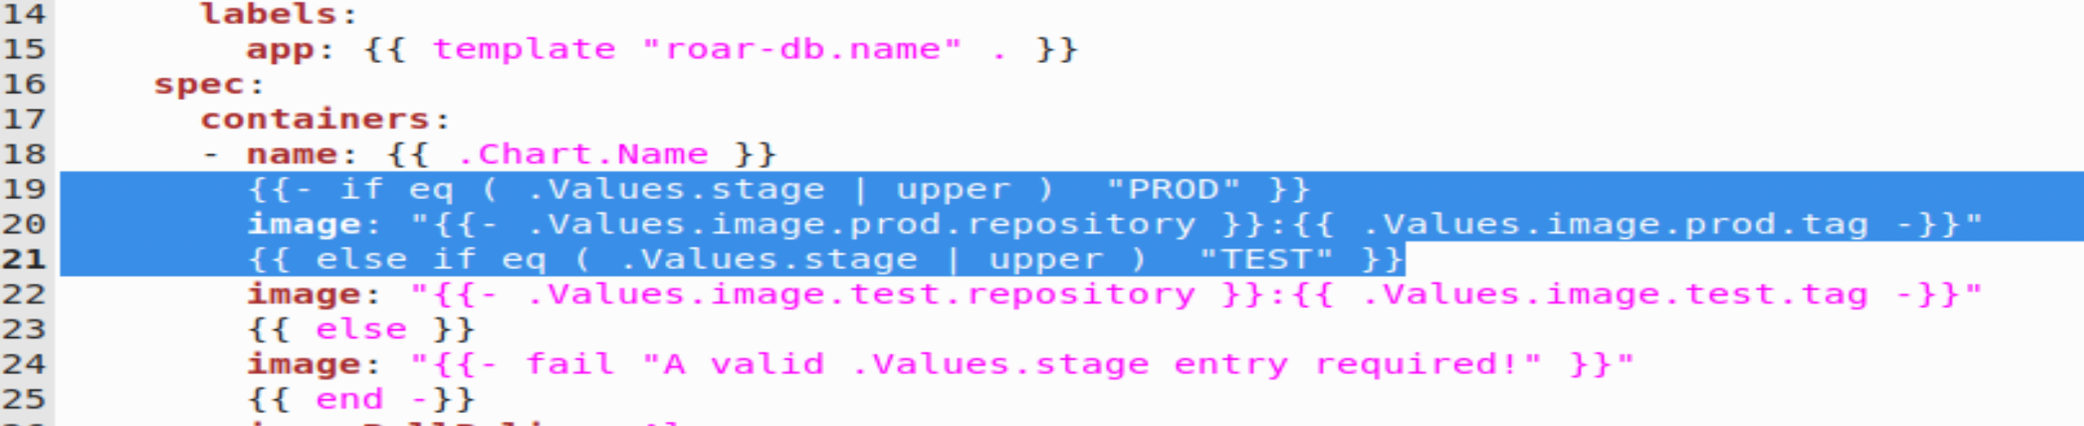

1. Save your changes and try running the command with the lower-case setting again. This time it should work.

$ helm install --set roar-db.stage=test --dry-run FOO . | grep image -n3

1. What happens if we don't pass in a setting for stage? Try it and see.

$ helm install --dry-run FOO . | grep image -n3

We get an error because we don't have any value set and one of our functions fails because it doesn't have the correct type to compare.

1. We'd rather have a default that works. Let's set one up in the *values.yaml* of the parent project that will be passed in to the child project. In the *helm-ws/roar-web2* directory, edit the *values.yaml* file and add the settings below.

$ gedit ~/helm-ws/roar-web2/values.yaml

<add these lines>

roar-db:

stage: PROD

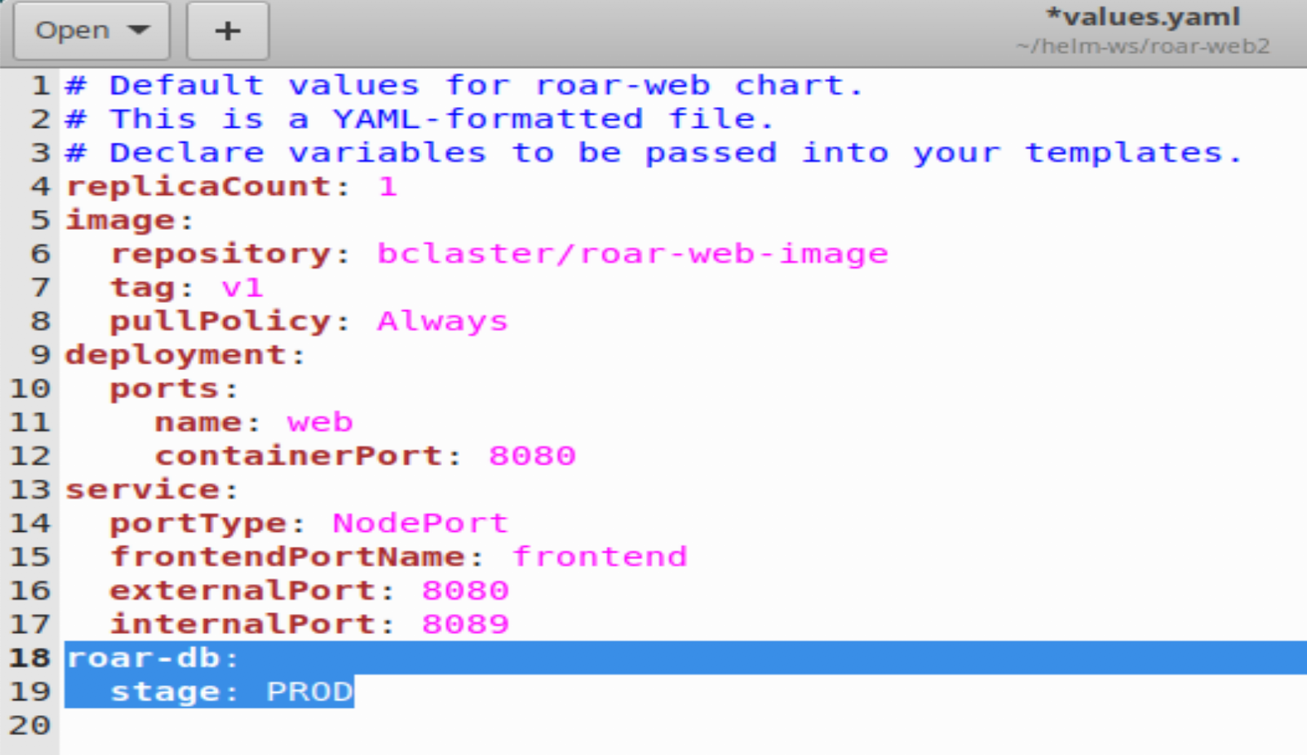

1. Now try running the same command as you did in step 8.

$ helm install --dry-run FOO . | grep image -n3

Notice that this time it worked. Also notice that the value was passed down from the parent project.

1. Finally let's try deploying a running test instance of our application and a running instance of the prod version of our application.

$ k create ns roar-prod

$ ﻿helm install --set roar-db.stage=PROD roar-prod .

$ k create ns roar-test

﻿$ helm install --set roar-db.stage=TEST roar-test .

1. Now, you can get the NodePort for both versions. and open them in a browser to see the results.

$ k get svc -n roar-prod | grep web

$ k get svc -n roar-test | grep web

1. As a reminder, the port numbers that are > 30000 are the ones you want. You can open each of them in a browser at [http://localhost:<nodeport>/roar/](http://localhost:%3cnodeport%3e/roar/) and view the different instances.

THE END – THANKS!